Code 3.1.1 } Write a Python program that prompts the user to enter three integers. Print the largest of the three integers.

Algorithm :
Step 1 : start
Step 2 : taking input of three integers
Step3 : calculating the max of them
Step 4 : stop

Code :
A = float(input())
B = float(input())
C = float(input())
Print(max(A,B,C))

Flowchart :
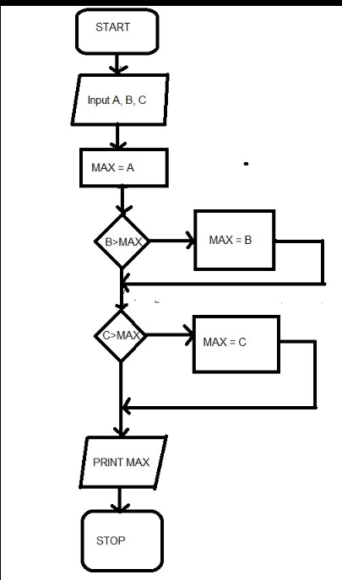

Codetantra :
